1. Download node js
2. Install mysql driver npm install mysql in same folder of project
3. Create Connection
4. Error during connection with db

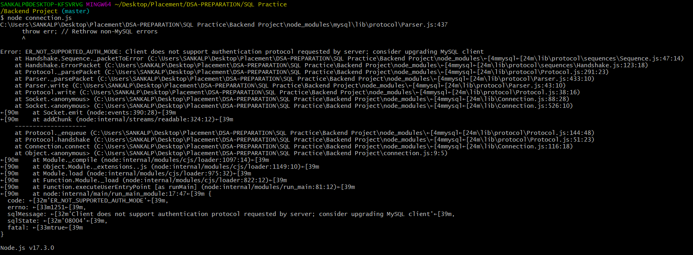

1. <https://stackoverflow.com/questions/50093144/mysql-8-0-client-does-not-support-authentication-protocol-requested-by-server?noredirect=1&lq=1>
2. <https://www.tutorialspoint.com/adding-mysql-to-windows-path>
3. \sql \connect --mysql root@localhost:3306
4. SOURCE C:/temp/world.sql;
5. mysql.exe -u root -e "source **'**<path>**'**"
6. The outer, double quotes, wrap up the statement to be executed (for the benefit of the operating system) and the inner, single ones, wrap up the file path (for the benfit of MySQL).
7. <https://nodejs.org/en/knowledge/command-line/how-to-prompt-for-command-line-input/>
8. <https://stackoverflow.com/questions/14284494/mysql-error-1264-out-of-range-value-for-column>
9. <https://stackoverflow.com/questions/49368756/nodejs-and-mysql-how-to-use-nodejs-variable-in-mysql-insert-statement>
10. <https://www.geeksforgeeks.org/routing-in-node-js/>
11. <https://stackoverflow.com/questions/14753321/add-auto-increment-id-to-existing-table#14753520>
12. <https://attacomsian.com/blog/nodejs-read-write-json-files>
13. <https://www.geeksforgeeks.org/difference-between-node-js-require-and-es6-import-and-export/?ref=leftbar-rightbar>
14. <https://websolutionstuff.com/post/how-to-get-current-date-and-time-in-node-js>
15. <https://stackoverflow.com/questions/14220321/how-to-return-the-response-from-an-asynchronous-call>
16. <https://www.geeksforgeeks.org/node-js-response-write-method/>
17. <https://stackoverflow.com/questions/25623041/how-to-configure-dynamic-routes-with-express-js?noredirect=1&lq=1>
18. <https://www.youtube.com/watch?v=yXEesONd_54>
19. <https://javascript.plainenglish.io/problem-with-returning-values-from-async-await-function-javascript-e99c94a47ca5>
20. <https://github.com/achowba/node-mysql-crud-app>
21. <https://stackoverflow.com/questions/56329364/how-can-i-export-the-result-returned-from-a-mysql-query>
22. <https://stackoverflow.com/questions/46715484/correct-async-function-export-in-node-js>
23. <https://www.geeksforgeeks.org/import-and-export-in-node-js/>
24. <https://www.geeksforgeeks.org/express-js-app-get-request-function/>
25. <https://stackoverflow.com/questions/9177049/express-js-req-body-undefined>
26. <https://www.geeksforgeeks.org/body-parser-middleware-in-node-js/>
27. <https://expressjs.com/en/resources/middleware/body-parser.html>
28. <https://www.tutorialspoint.com/expressjs/expressjs_authentication.htm>
29. <https://stackoverflow.com/questions/15393935/boolean-in-an-if-statement>
30. <https://stackoverflow.com/questions/42020298/nodejs-returning-true-false-inside-function>
31. <https://www.geeksforgeeks.org/how-to-make-js-variables-accessible-to-ejs-files/>
32. <https://stackoverflow.com/questions/46009870/how-to-reset-password-of-root-user-in-mysql-workbench>
33. <https://stackoverflow.com/questions/11942945/in-a-mysql-schema-what-is-the-meaning-of-auto-increment-3>
34. <https://duckduckgo.com/?q=create+table+in+schema+mysql&t=brave&ia=web&iax=qa>
35. <https://www.geeksforgeeks.org/how-to-serve-static-content-using-node-js/>
36. Accessing static files are very useful when you want to put your static content accessible to the server for usage
37. <https://www.geeksforgeeks.org/how-to-run-node-js-server/>
38. <https://stackoverflow.com/questions/7310176/including-a-js-file-in-node-js>
39. The script you're trying to include is not a node.js module, so you should make a few changes to it. As there is no shared global scope between the modules in node.js you need to add all the methods you want to access to the exports object. If you add this line to your latlon.js file.
40. <https://stackoverflow.com/questions/1905470/cannot-delete-or-update-a-parent-row-a-foreign-key-constraint-fails>
41. <https://www.youtube.com/watch?v=UObINRj2EGY>
42. <https://stackoverflow.com/questions/1905470/cannot-delete-or-update-a-parent-row-a-foreign-key-constraint-fails>
43. Delete in country page not working
44. css images js not static rendering
45. <https://stackoverflow.com/questions/54495711/async-await-vs-then-which-is-the-best-for-performance#54497100>
46. <https://stackoverflow.com/questions/5317889/sql-keys-mul-vs-pri-vs-uni>
47. <https://www.w3schools.com/sqL/func_sqlserver_dateadd.asp>
48. <https://www.tutorialspoint.com/momentjs/momentjs_quick_guide.htm>
49. <https://duckduckgo.com/?q=require(%27datejs%27)%3B&t=brave&ia=web>
50. <https://stackoverflow.com/questions/61318361/how-to-convert-date-format-like-this-fri-apr-20-2020-000000-gmt0530-india-st>
51. <https://www.geeksforgeeks.org/express-js-app-use-function/>
52. <https://stackoverflow.com/questions/44524424/get-http-localhost3000-404-not-found>
53. Middleware functions are executed sequentially, therefore the order of middleware inclusion is important.
54. <https://expressjs.com/en/4x/api.html#app.use>
55. Mount the middleware at “/static” to serve static content only when their request path is prefixed with “/static”:

[https://www.cdnpkg.com/twitter-bootstrap/file/bootstrap.min.css.map/#](https://www.cdnpkg.com/twitter-bootstrap/file/bootstrap.min.css.map/)

<https://stackoverflow.com/questions/21652970/in-mysql-command-line-how-do-i-paste-from-the-clipboard-using-only-the-keyboard>

<https://www.geeksforgeeks.org/how-to-return-json-using-node-js/>

<https://stackoverflow.com/questions/53511974/javascript-fetch-failed-to-execute-json-on-response-body-stream-is-locked>

<https://javascript.plainenglish.io/frequency-counter-algorithm-b3fa98efe8ba>

<https://www.w3schools.com/Jsref/jsref_push.asp>

<https://stackoverflow.com/questions/174582/how-do-i-rename-a-column-in-a-database-table-using-sql>

<https://bobbyhadz.com/blog/javascript-referenceerror-alert-is-not-defined>

<https://stackoverflow.com/questions/2559318/how-to-check-for-an-undefined-or-null-variable-in-javascript>

https://stackoverflow.com/questions/23344320/there-isnt-anything-to-compare-nothing-to-compare-branches-are-entirely-diffe